1. **Date and Time Calculations**
2. **Days to Ship**

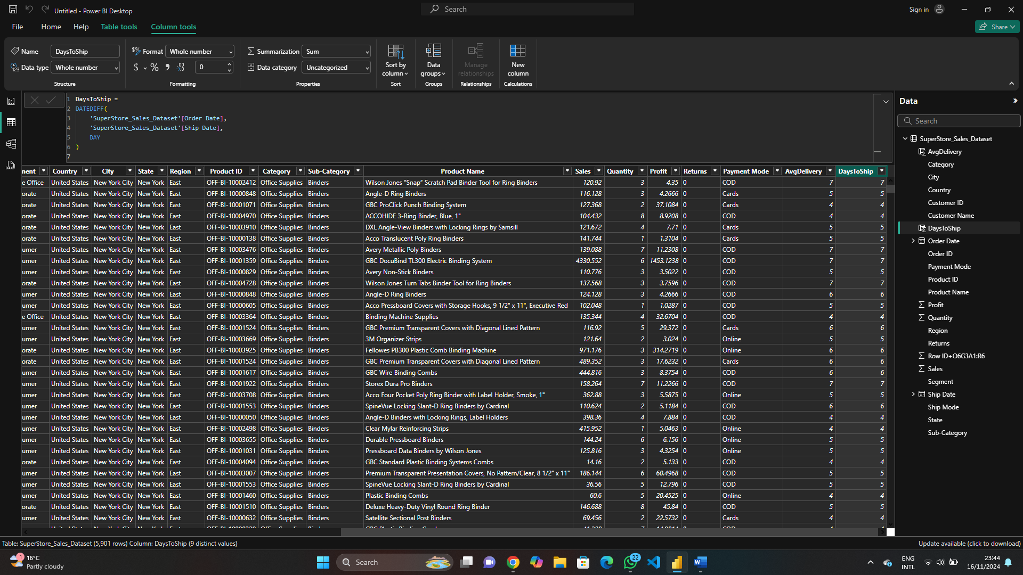

1. **Month of Order**

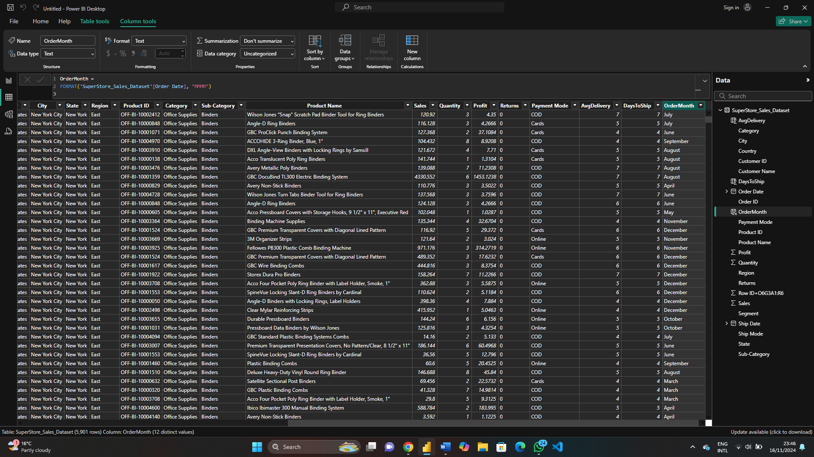

1. **Year of Order**

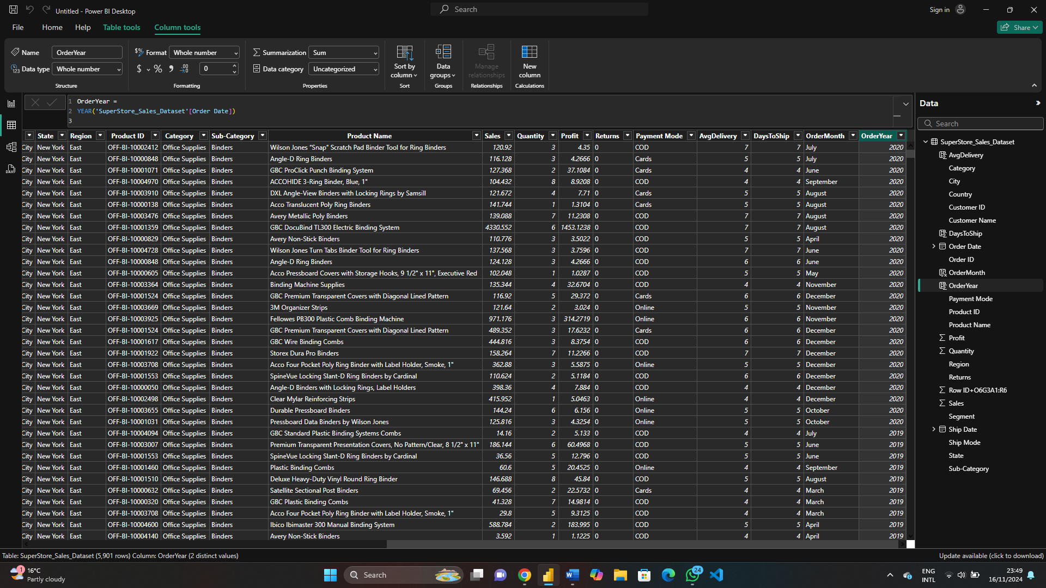

1. **Sales and Profit Calculations**
2. **Total Sales**

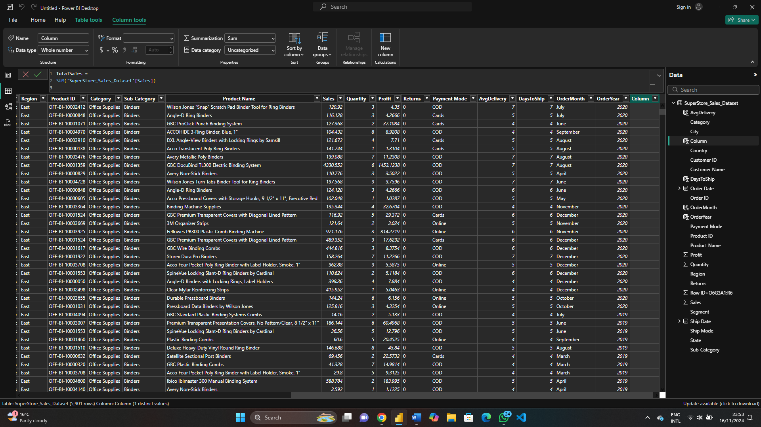

**b. Total Profit**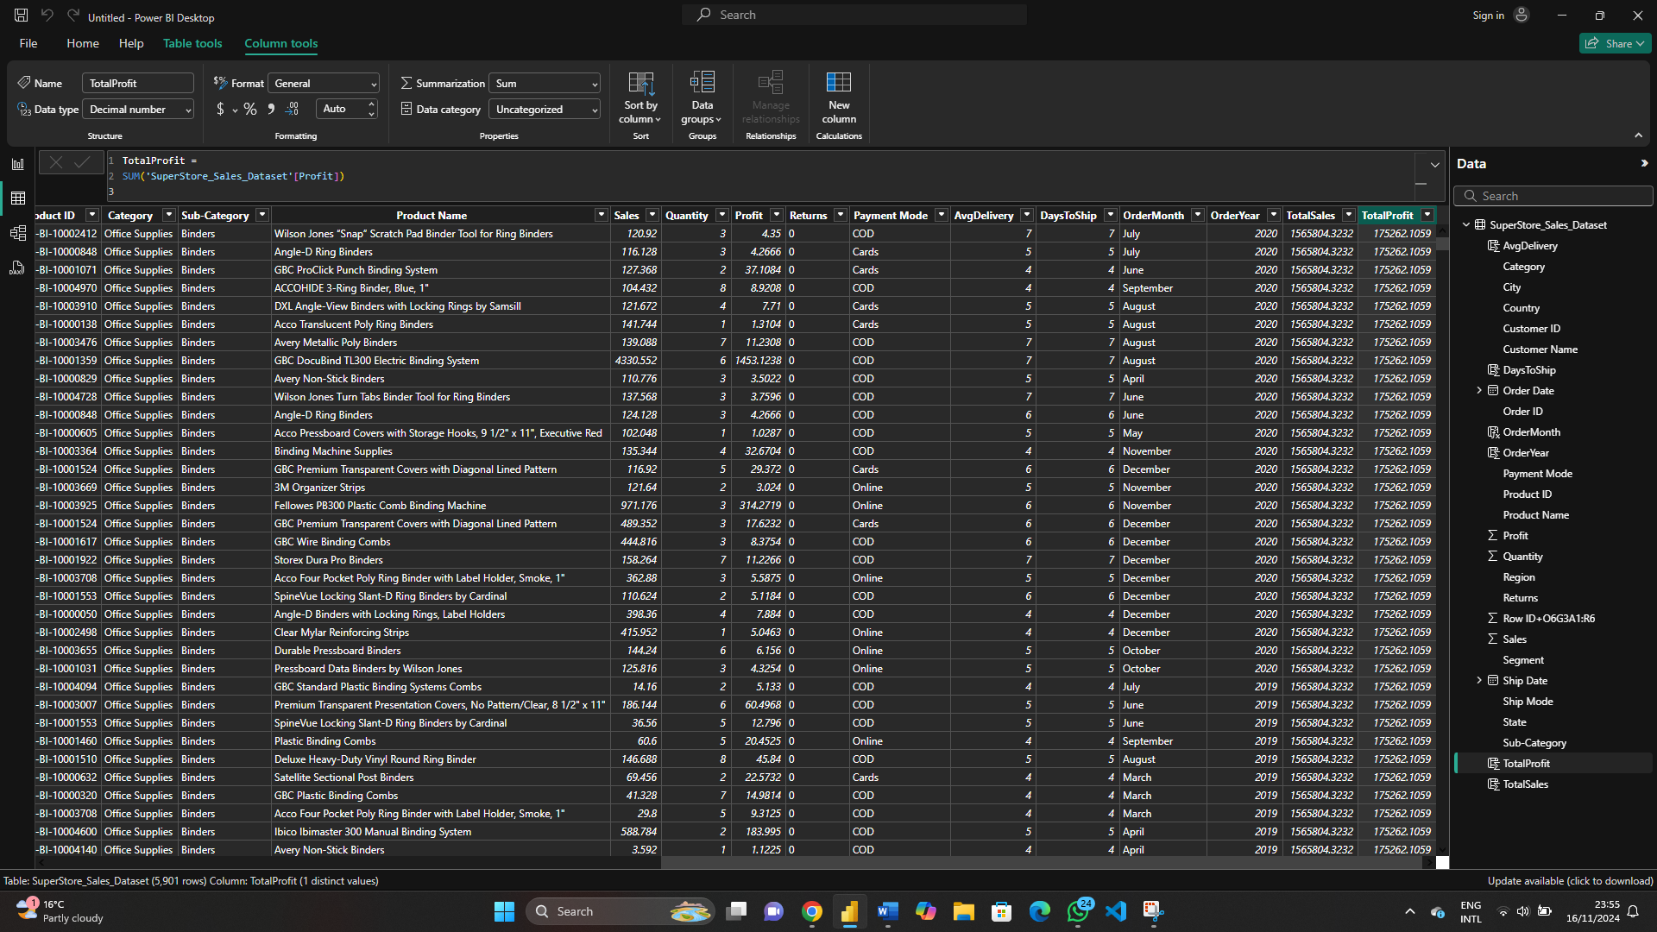

1. **Profit Margin**

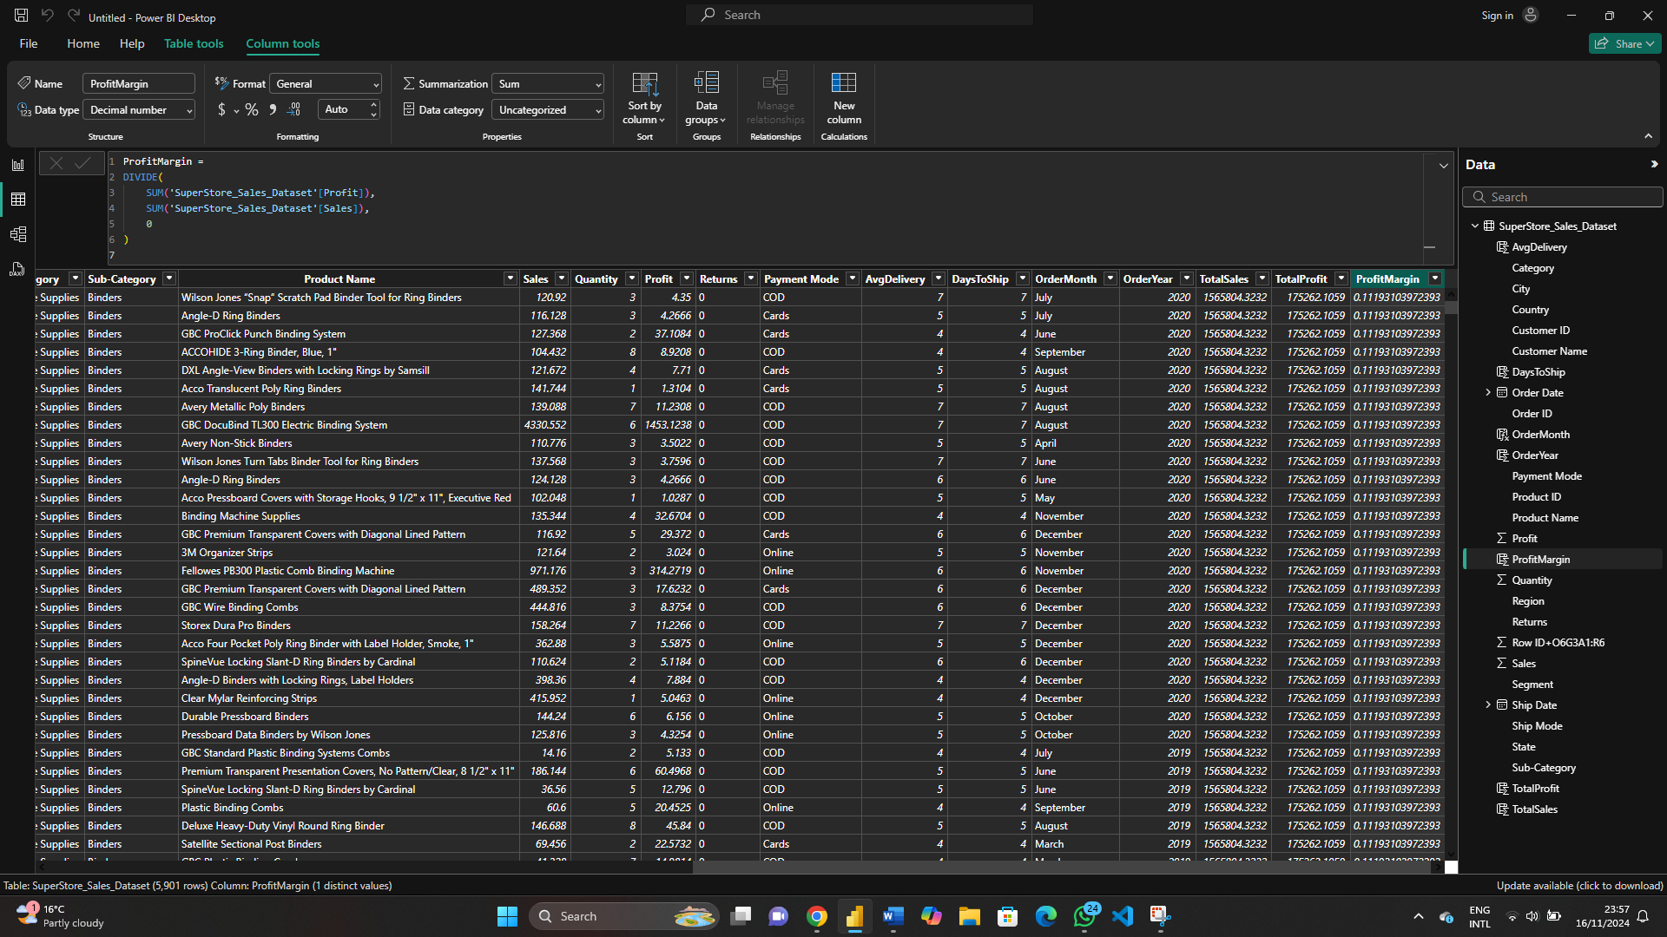

1. **Average Sales per Order**

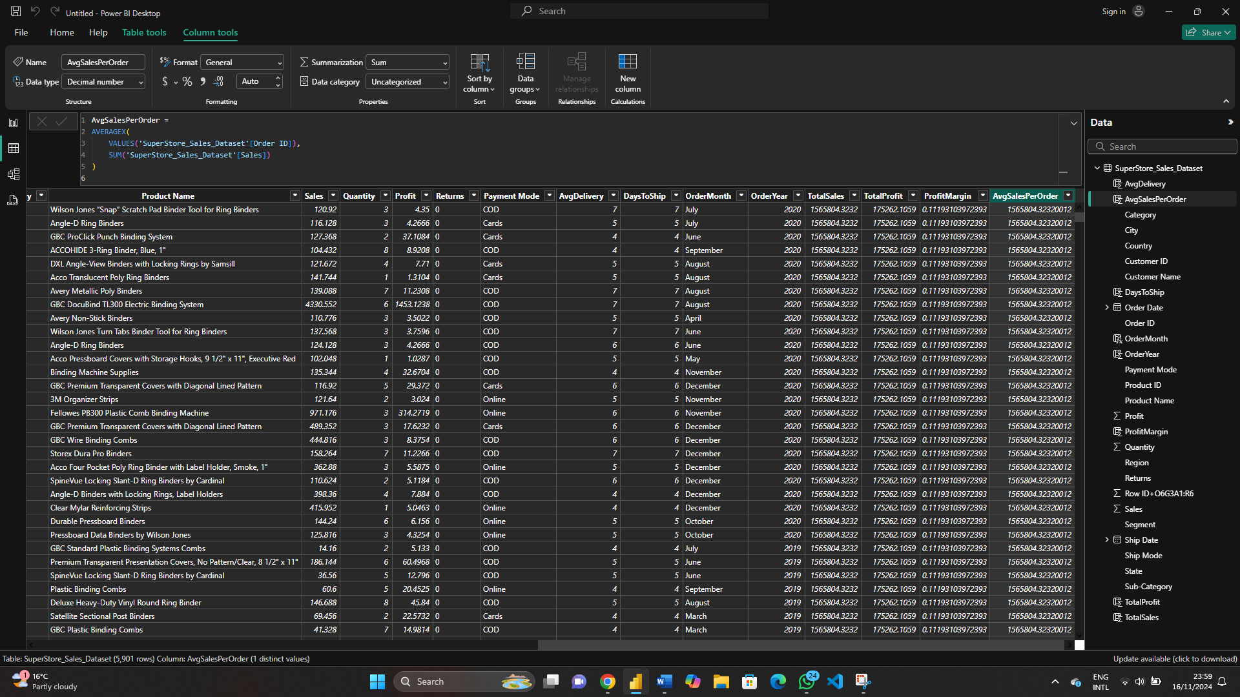

**3. Customer and Segment Analysis**

**a. Total Customers**

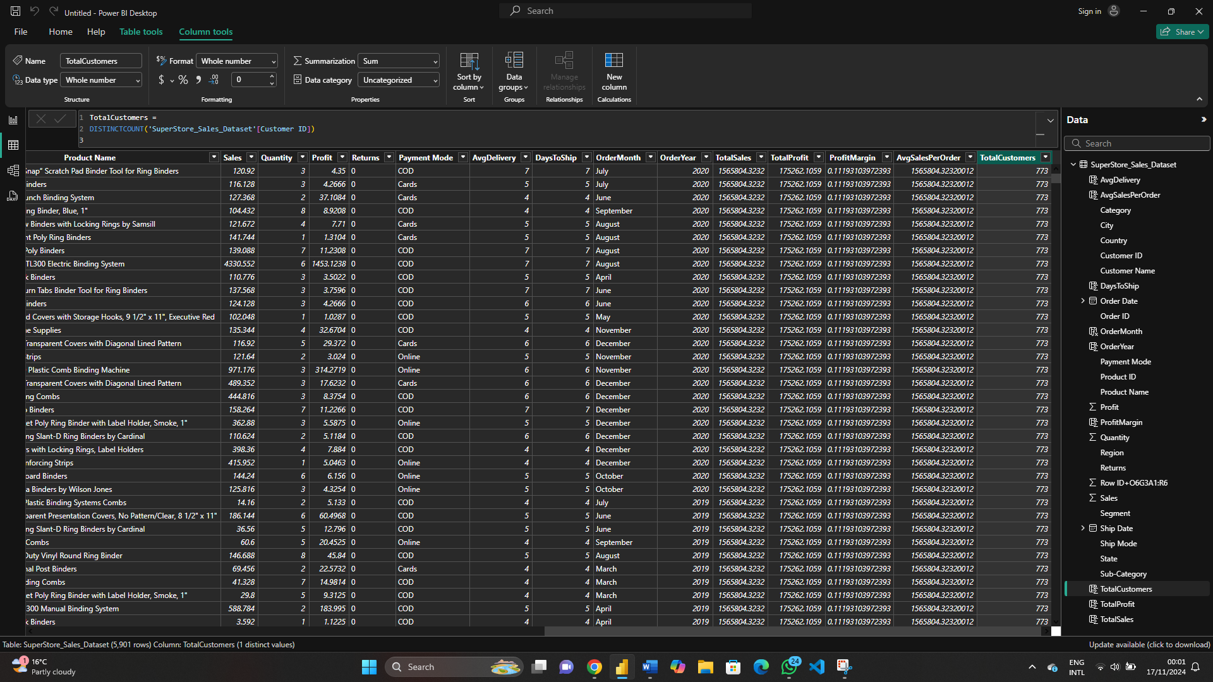

**b. Sales by Segment**

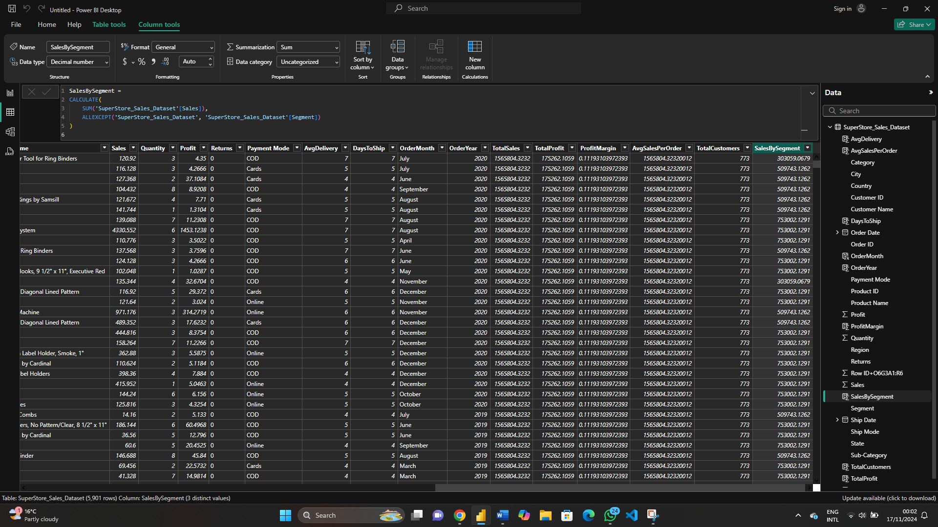

1. **Top Customer by Sales**

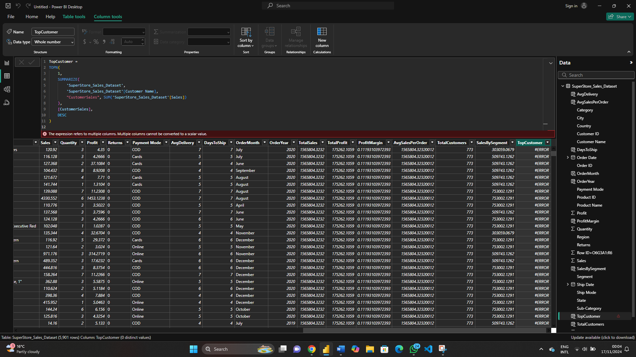

**4. Geographical Analysis**

**a. Sales by Region**

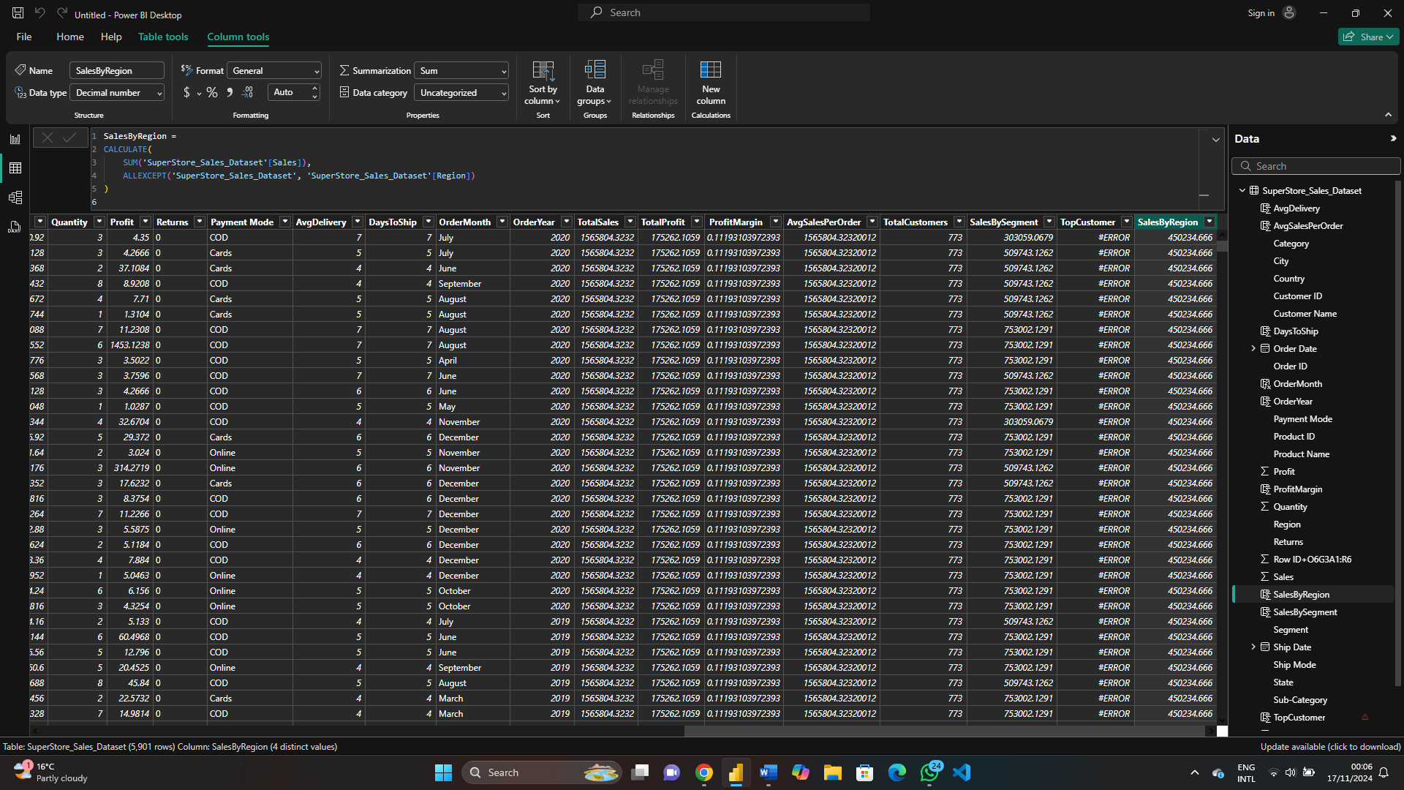

**b. Average Delivery Time**

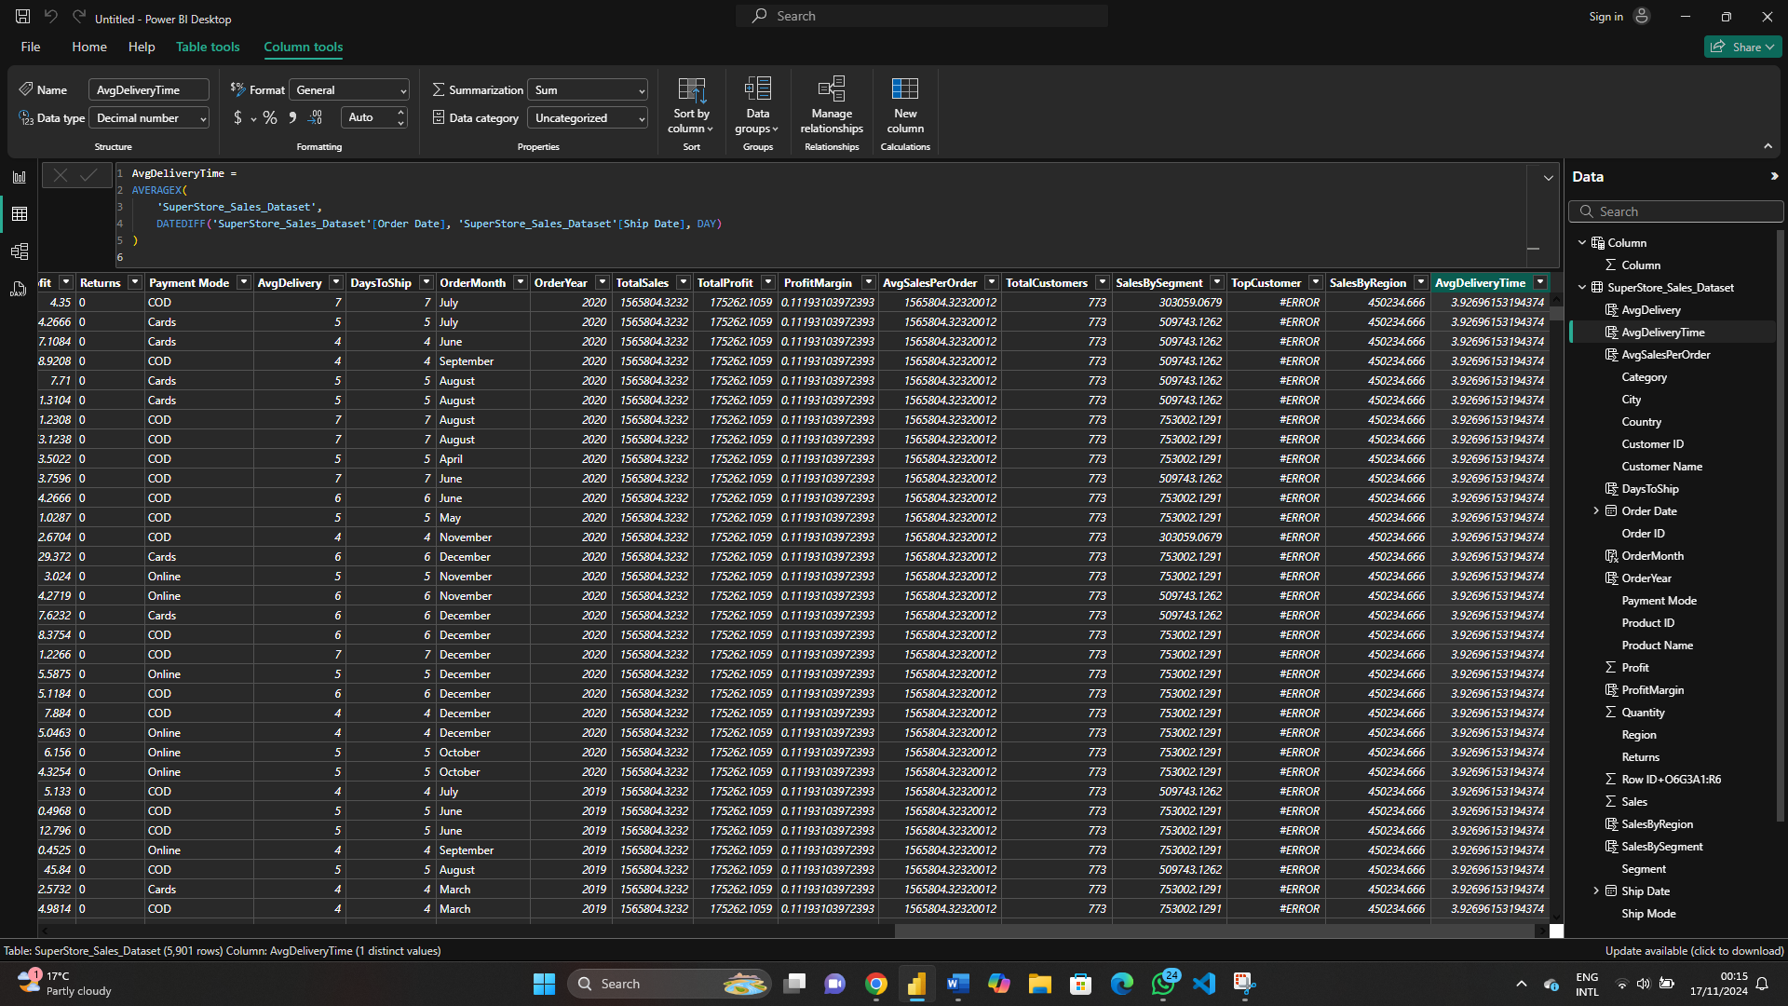

**Total Sales of Top-Selling Product**

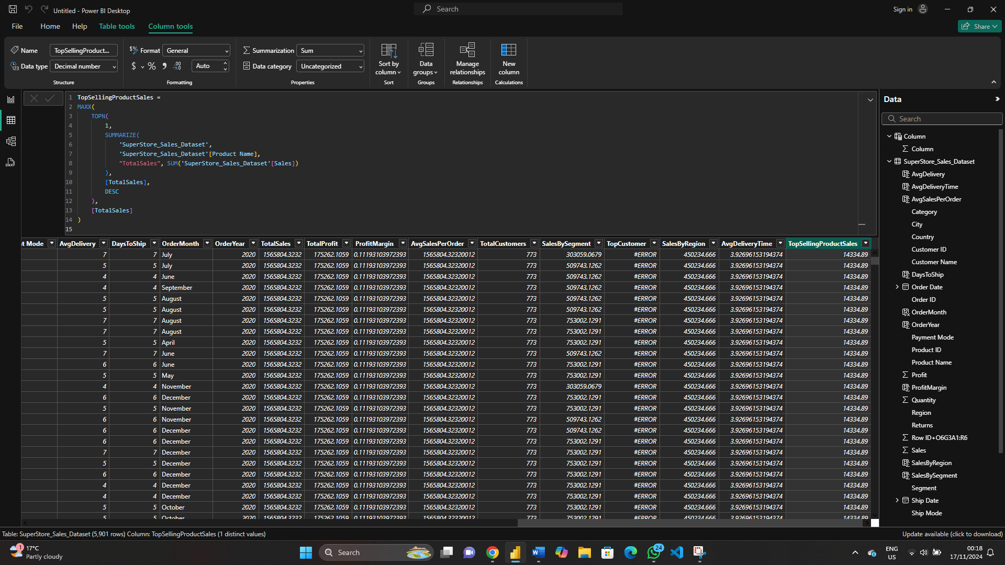

**Creating Table using DAX**

